**实验四 动态路由协议RIP的配置**

**一、构建拓补结构：**

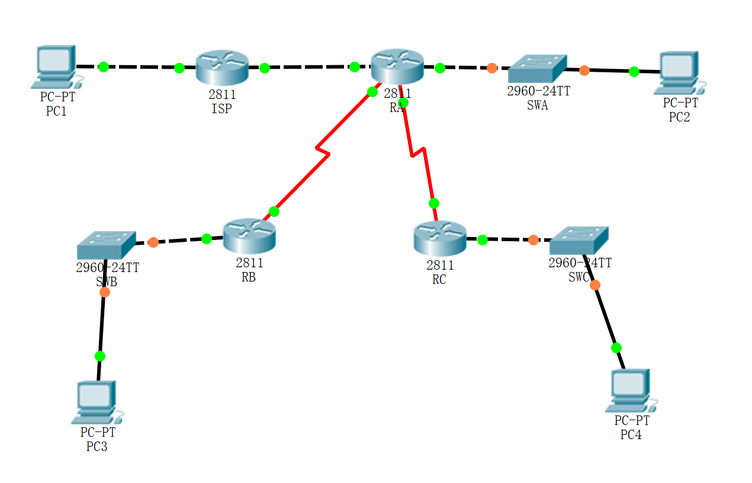

**二、基本链接关系和配置如下：**

|  |  |  |  |  |
| --- | --- | --- | --- | --- |
| **设备** | **端口号** | **端口IP地址** | **下联设备（端口）** | **下联端口地址** |
| **ISP** | f0/0 | 192.168.10.1 | pc1 | 192.168.10.10 |
| **ISP** | f0/1 | 192.168.100.1 | RA(f0/1) | 192.168.100.2 |
| **RA** | s1/0 | 192.168.110.1 | RB(s1/0) | 192.168.110.2 |
| **RA** | s1/1 | 192.168.120.1 | RC(s1/1) | 192.168.120.2 |
| **RA** | f0/0 | 192.168.20.1 | swA-pc2 | 192.168.20.10 |
| **RB** | f0/0 | 192.168.30.1 | swB-PC3 | 192.168.30.10 |
| **RC** | f0/0 | 192.168.40.1 | swC-pc4 | 192.168.40.10 |

**三、交换机的基本配置介绍：**

1、动态路由配置RA：

Router(config)#router rip

Router(config-router)#network 192.168.20.0

Router(config-router)#network 192.168.100.0

Router(config-router)#network 192.168.110.0

Router(config-router)#network 192.168.120.0

Router(config-router)#exit

Router#write

2、动态路由配置RC：

Router(config)#router rip

Router(config-router)#network 192.168.40.0

Router(config-router)#network 192.168.120.0

Router(config-router)#end

Router#write

3、动态路由配置ISP：

Router(config)#router rip

Router(config-router)#network 192.168.10.0

Router(config-router)#network 192.168.100.0

Router(config-router)#end

Router#write

4、动态路由配置RB：

Router(config)#router rip

Router(config-router)#network 192.168.30.0

Router(config-router)#network 192.168.110.0

Router(config-router)#end

Router#write

**四、测试（PC1与PC4通信，RA配置动态路由协议RIP前后的路由表比较）**

**[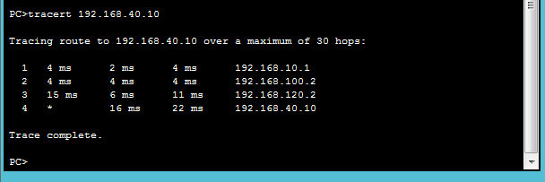](http://photo.blog.sina.com.cn/showpic.html#blogid=70bc5e240101e6xd&url=http://s10.sinaimg.cn/orignal/70bc5e24tcebbcaf726e9)**